* **Understanding x and y coordinates on canvas [Section-1]**

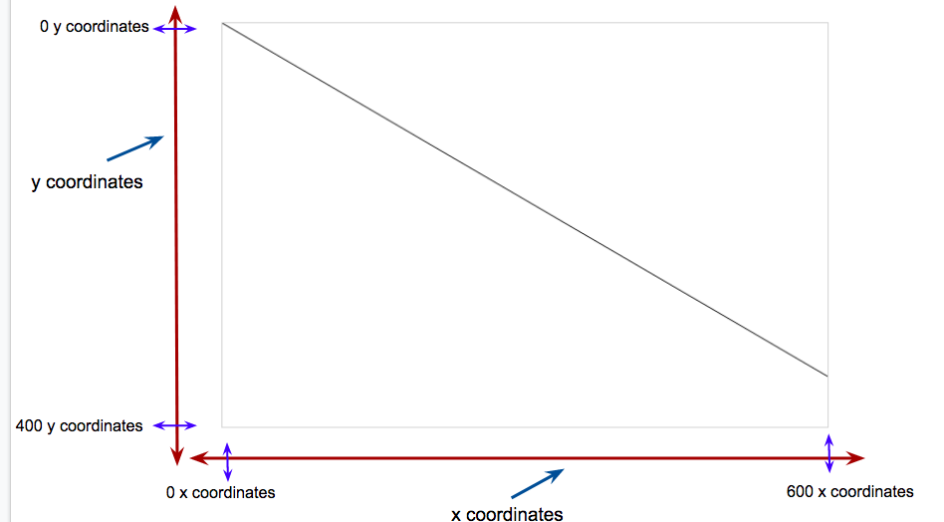

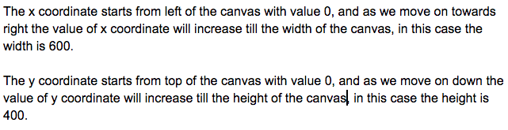

* **Understanding Canvas, moveTo and lineTo with respect to x and y coordinates [Section-2]**

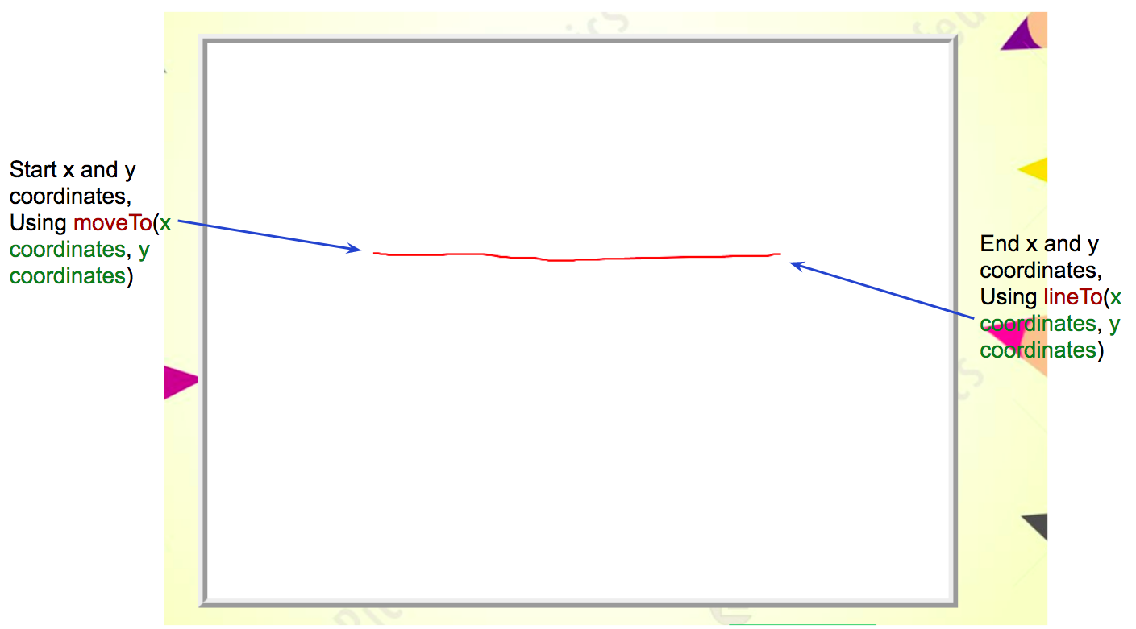

* **Code for mousedown event**

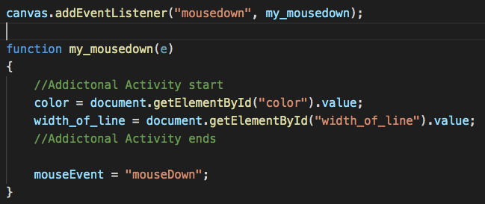

* **Code for mouseleave event**

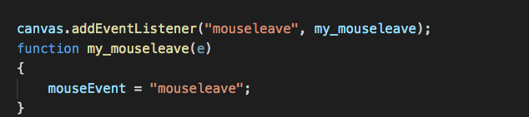

* **Code for mouseup event**

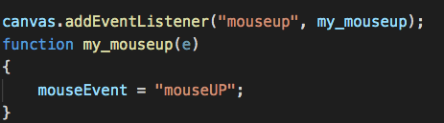

* **Code for mousemove event**

